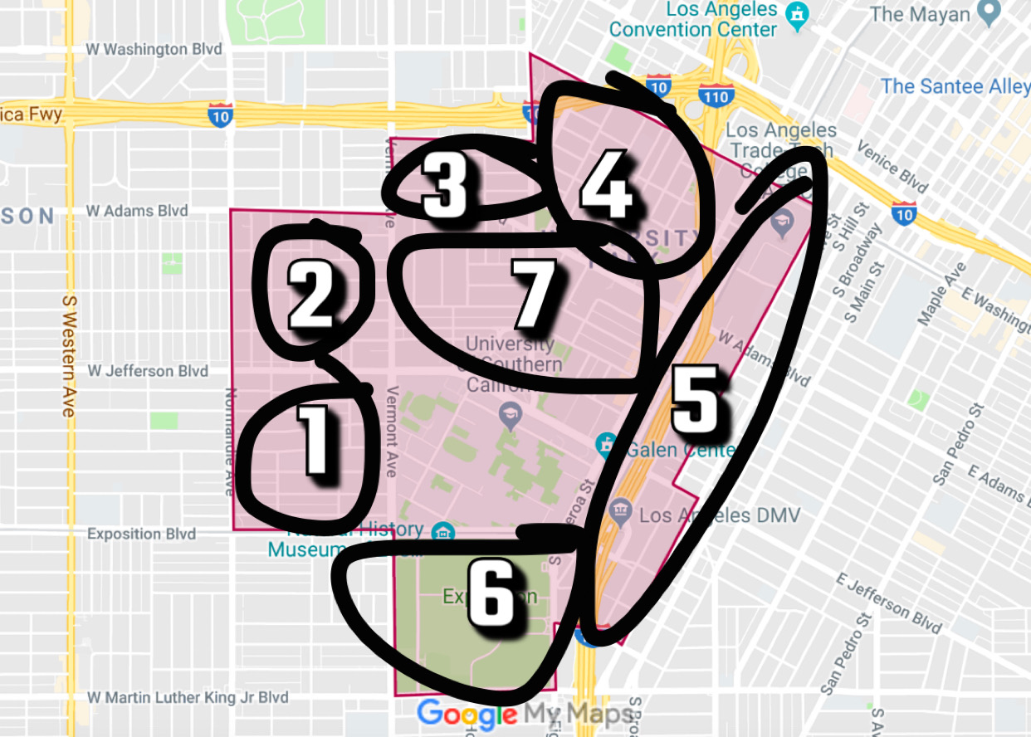

TOP - RIGHT - BOTTOM - LEFT

Zone 1 (Jefferson - Vermont - Exposition - Normandie)
- Affordable housing, be more careful on this side
- More locals than other zones – still a good mix of students and locals
- Had campus plaza (Taco Bell, Post Office, Supercuts, Boba)
- Has Masjid Omar ibn Al-Kattab and Senshin Buddhist Temple

Zone 2 (Adams - Vermont - Jefferson - Normandie)
- Lot of stuff on Vermont (3 Brothers Bike Shop, Manas, Ralphs / Taco Truck)
- Prime real estate close to campus

Zone 3 (22nd Street - Hoover - Adam - Vermont)
- La Barca
- More locals than other zones – still a good mix of students and locals

Zone 4 (Washington- Figueroa - Adam - Hoover)
- More locals than other zones – still a good mix of students and locals
- 23st Cafe

Zone 5 (Washington- Figueroa - Adam - Hoover)
- Drunk station after frat parties (Panda Express, Taco stand, Dominos)
- Blaze / Yogurtland / El Huero
- Galen Center, Starbuck
- Lot of Luxury / Brand name apartments on the Figueroa strip (Gateway, Lorenzo, Hub LA, 505, USC Hotel)
- LATTC

Zone 6 (Exposition - Figueroa - Martin Luther King - Vermont)
- Exposition Park
- LA Memorial Coliseum (Gameday, Football)
- BMO Stadium
- California Science Center, California National History Museum, Lucas Museum of Narrative Art), Rose Garden
- Soboroff Sports Field at Expo
- Foundation / John C. Swim Stadium

Zone 7 (W Adam - Figueroa - Jefferson - Vermont)
- Prime Time → USC Village, Frat Row, Shrine Auditorium

